Phase-2 DataFlowDiagram

|  |  |
| --- | --- |
| Date | 30October2022 |
| TeamID | B2-2M4E |
| ProjectName | Project-InventoryManagementSystemforRetailers |
| MaximumMarks | 4Marks |

**DataFlowDiagram**

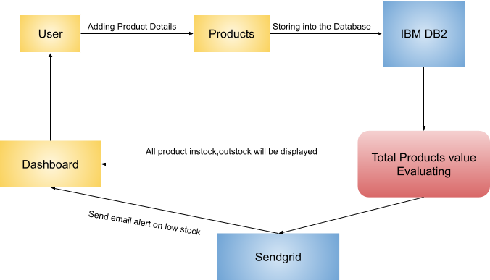

**UserStories**

|  |  |  |  |  |  |  |
| --- | --- | --- | --- | --- | --- | --- |
| **UserType** | **Functional**  **Requirement(Epic)** | **UserStoryNumber** | **UserStory/Task** | **Acceptancecriteria** | **Priority** | **Release** |
| Retailer(Webuser) | Registration | USN-1 | Asauser,Icanregister for theapplicationby  enteringmyemail,password,andconfirmingmypassword. | Iwillberedirectedtologinpage | High | Sprint-1 |
|  | USN-2 | Asauser,IwillreceiveconfirmationemailonceIhaveregisteredfortheapplication | Icanreceiveconfirmationemail&clickconfirm | High | Sprint-1 |
|  | USN-3 | Asauser,IcanregisterfortheapplicationthroughFacebook | Icanregister&accessthedashboard with FacebookLogin | Low | Sprint-2 |
|  | USN-4 | Asauser,IcanregisterfortheapplicationthroughGmail | IcanverifytheOTPnumber | Medium | Sprint-1 |
|  | Login | USN-5 | Asauser,Icanlogintotheapplicationbyenteringemail&password | Icanaccessmyaccount/dashboard | High | Sprint-1 |
|  | Dashboard | USN-6 | Asauser,Icanupdatestockin&outcountdetails | Updation can be madethroughbarcodescanning | High | Sprint-2 |
|  | Dashboard | USN-7 | Asauser,Icancheckthelowstockdetailsthroughalertmessage | Alert message can bereceivedbyregisteredmail | High | Sprint-1 |
|  |  | USN-8 | Asauser,Icancheckthetotalproductdetails | Icanviewthevalueoftotalproductsinthestock | Medium | Sprint-2 |
|  |  | USN-9 | Asauser,Icancheckthehighdemandproductdetails | Icanupdatesalesdetailsoftheproducts | High | Sprint-2 |
|  |  | USN-10 | Asauser,Icangeneratetheinvoicedetails | Icanaddincomingstockdetails | High | Sprint-1 |